Data Mining lab

Assignment 6

Name: Ayush Kumar

Regno: 20214284

Group: CSE-6B1

1. Compute the split point for each attribute in the dataset using the following strategies:

a. Information Gain

# b. Gini Indexes

c. Gain Ratio

import pandas as pd import numpy as np

from sklearn.tree import DecisionTreeClassifier # Load the dataset

df = pd.read_csv("vehicle.csv")

# Preprocessing (if required) # Check for missing values print(df.isnull().sum())

# Handle missing values (if any)

# For simplicity, let's drop rows with missing values df.dropna(inplace=True)

# Separate features (X) and target variable (y)

X = df.drop(columns=['class']) # Assuming 'class' is the target variable y = df['class']

# Initialize the decision tree classifier clf = DecisionTreeClassifier()

# Fit the classifier to the data clf.fit(X, y)

# Function to compute Information Gain def information_gain(y, y_splits):

entropy_parent = entropy(y) total_instances = len(y)

weighted_entropy_children = sum((len(y_split) / total_instances) * entropy(y_split) for y_split in y_splits)

return entropy_parent - weighted_entropy_children # Function to compute Gini Index

def gini_index(y, y_splits): gini_parent = gini_impurity(y) total_instances = len(y)

weighted_gini_children = sum((len(y_split) / total_instances) * gini_impurity(y_split) for y_split in y_splits)

return gini_parent - weighted_gini_children

# Function to compute entropy def entropy(y):

classes, counts = np.unique(y, return_counts=True) probabilities = counts / len(y)

return -sum(p * np.log2(p) for p in probabilities)

# Function to compute Gini impurity def gini_impurity(y):

classes, counts = np.unique(y, return_counts=True) probabilities = counts / len(y)

return 1 - sum(p**2 for p in probabilities)

# Function to compute split points using Information Gain, Gini Index, and Gain Ratio

def compute_split_points(X, y): split_points = {}

for col in X.columns:

# Assuming each attribute is numeric values = X[col].unique()

for value in values:

# Split the dataset based on the attribute value left_indices = X[col] < value

right_indices = ~left_indices

y_splits = [y[left_indices], y[right_indices]] # Compute metrics for split points

info_gain = information_gain(y, y_splits) gini_idx = gini_index(y, y_splits)

gain_ratio = info_gain / (entropy(X[col]) + 1e-10) # Add small value to avoid division by zero

split_points[(col, value)] = {'Information Gain': info_gain, 'Gini Index': gini_idx, 'Gain Ratio': gain_ratio}

return split_points

# Compute split points for each attribute split_points = compute_split_points(X, y)

# Print split points

for key, value in split_points.items(): print(f"Split Point for {key}: {value}")

# Design module for creating the decision tree and its representation in graphical format for the following cases:

* 1. Binary Tree (each node split into exactly two branches).

# General Tree (each node may split into more than two branches depending on count nominal labels corresponding attributes).

import pandas as pd

from sklearn.tree import DecisionTreeClassifier

from sklearn.model_selection import train_test_split

from sklearn.metrics import accuracy_score, classification_report from sklearn.tree import export_graphviz

import graphviz

# Load the dataset

df = pd.read_csv("vehicle.csv")

# Check for missing values before preprocessing print("Missing values before preprocessing:") print(df.isnull().sum())

# Drop rows with missing values df.dropna(inplace=True)

# Check for missing values after preprocessing print("\nMissing values after preprocessing:") print(df.isnull().sum())

# Split the dataset into features and target variable X = df.drop(columns=['class'])

y = df['class']

# Split the dataset into training and testing sets

X_train, X_test, y_train, y_test = train_test_split(X, y, test_size=0.2, random_state=42)

# Initialize the decision tree classifier clf = DecisionTreeClassifier()

# Fit the classifier to the training data clf.fit(X_train, y_train)

# Predict the labels of the test set y_pred = clf.predict(X_test)

# Evaluate the model

accuracy = accuracy_score(y_test, y_pred) print("\nAccuracy:", accuracy) print("\nClassification Report:") print(classification_report(y_test, y_pred))

# Visualize the decision tree

dot_data = export_graphviz(clf, out_file=None,

feature_names=X.columns, class_names=y.unique(), filled=True, rounded=True, special_characters=True)

graph = graphviz.Source(dot_data) graph.render("vehicle_decision_tree", format='png', cleanup=True)

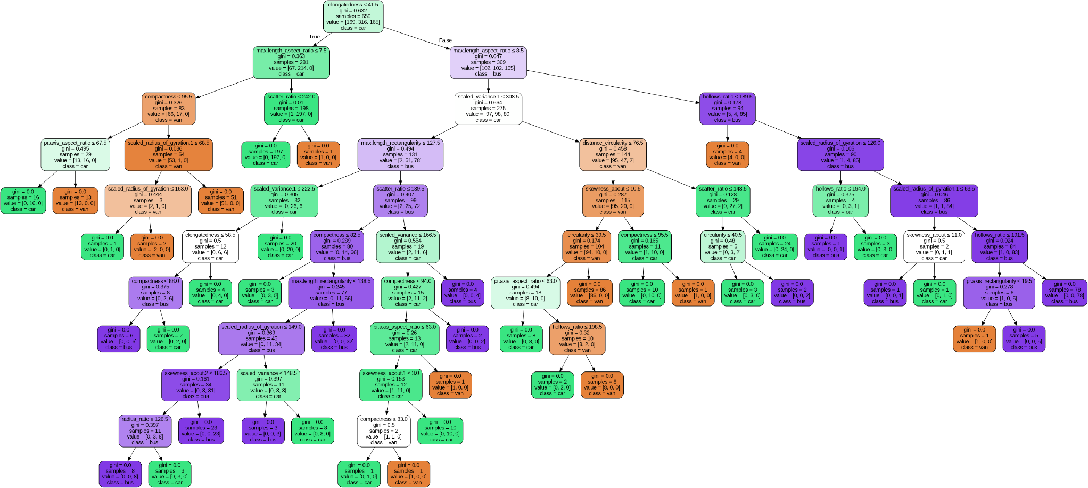

# Design module which predicts the class label of unknown and unseen data using tree traversal or any other techniques.

import pandas as pd

from sklearn.model_selection import train_test_split from sklearn.tree import DecisionTreeClassifier

from sklearn.metrics import accuracy_score

# Load the dataset

df = pd.read_csv('vehicle.csv')

# Drop rows with missing values df.dropna(inplace=True)

# Split dataset into features and target variable X = df.drop(columns=['class'])

y = df['class']

# Split data into training and testing subsets (80% training, 20% testing)

X_train, X_test, y_train, y_test = train_test_split(X, y, test_size=0.2, random_state=42)

# Create a decision tree classifier clf = DecisionTreeClassifier()

# Train the classifier on the training data clf.fit(X_train, y_train)

# Predict the classes of testing data y_pred = clf.predict(X_test)

# Evaluate accuracy

accuracy = accuracy_score(y_test, y_pred) print("Accuracy:", accuracy)